The time series considered is: r1mw

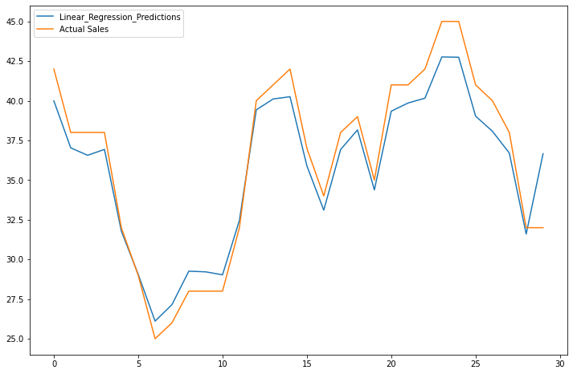

RMSE is: 1.5514567544708626

R2 is: 0.8873705337821877

MAPE is: 3.590887354514808

/usr/local/lib/python3.7/dist-packages/ipykernel_launcher.py:48: DataConversionWarning: A column-vector y was passed when a 1d array was expected. Please change the shape of y to (n_samples,), for example using ravel().

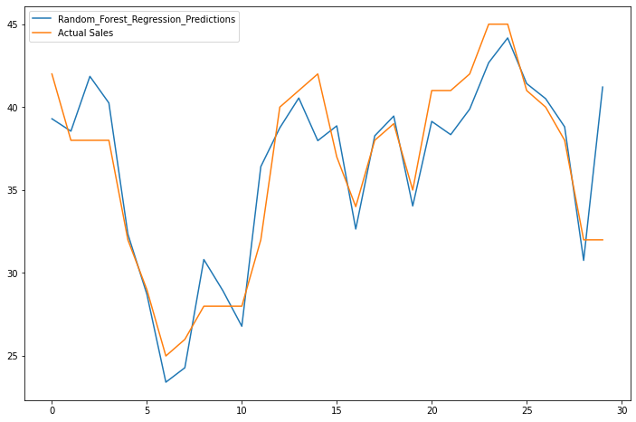

RMSE is: 2.5551881749309397

R2 is: 0.7863601334349813

MAPE is: 18.57284116450949

/usr/local/lib/python3.7/dist-packages/sklearn/utils/validation.py:760: DataConversionWarning: A column-vector y was passed when a 1d array was expected. Please change the shape of y to (n_samples, ), for example using ravel().

y = column_or_1d(y, warn=True)

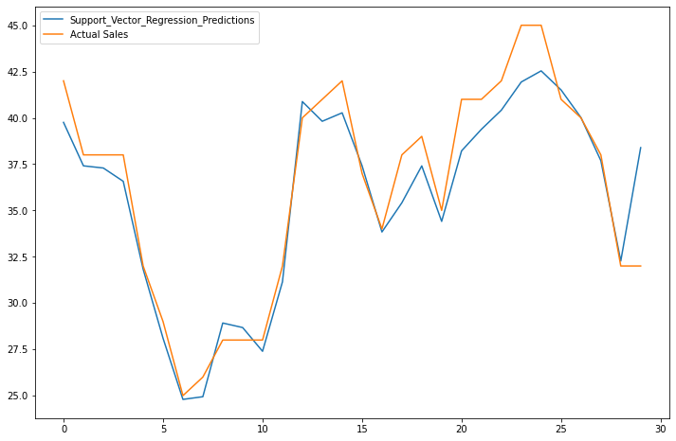

RMSE is: 1.7971471656248514

R2 is: 0.8779439471442146

MAPE is: 18.363965137871876

The time series considered is: r2mw

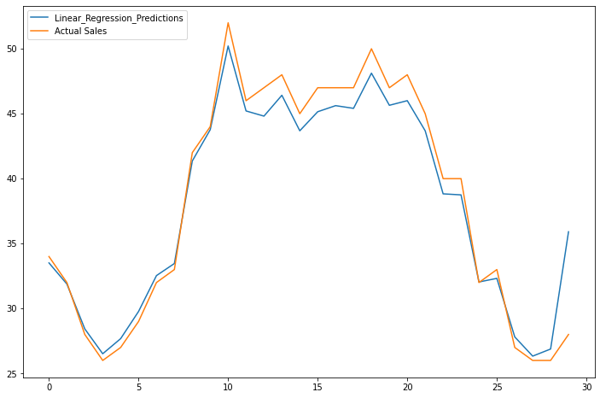

RMSE is: 1.8435018626425852

R2 is: 0.9420512311301651

MAPE is: 3.160237025603887

/usr/local/lib/python3.7/dist-packages/ipykernel_launcher.py:48: DataConversionWarning: A column-vector y was passed when a 1d array was expected. Please change the shape of y to (n_samples,), for example using ravel().

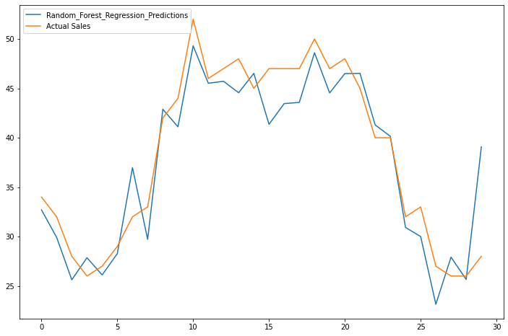

RMSE is: 3.195260715758053

R2 is: 0.8483479355247693

MAPE is: 28.138910250295684

/usr/local/lib/python3.7/dist-packages/sklearn/utils/validation.py:760: DataConversionWarning: A column-vector y was passed when a 1d array was expected. Please change the shape of y to (n_samples, ), for example using ravel().

y = column_or_1d(y, warn=True)

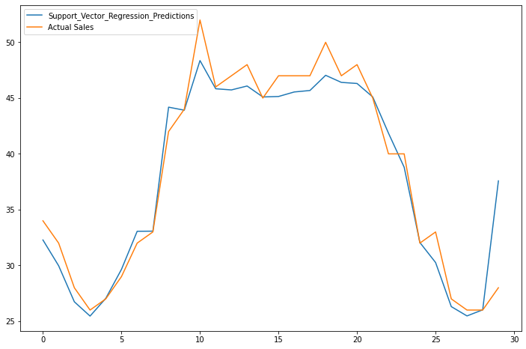

RMSE is: 2.295034662261541

R2 is: 0.9219167845479546

MAPE is: 27.394407573983386

The time series considered is: r3mw

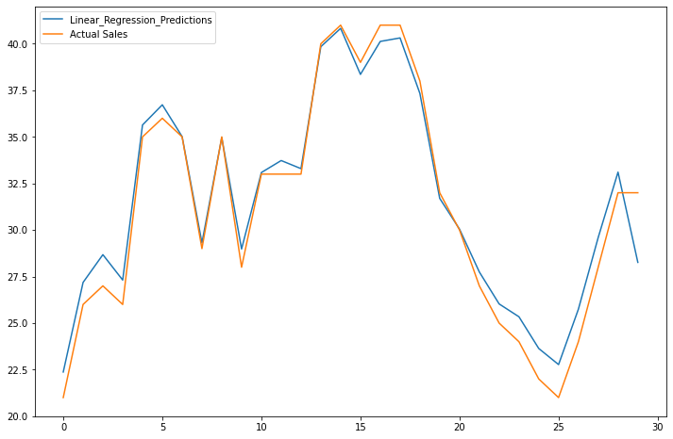

RMSE is: 1.1929162090342351

R2 is: 0.9514631655194133

MAPE is: 3.2470154470106234

/usr/local/lib/python3.7/dist-packages/ipykernel_launcher.py:48: DataConversionWarning: A column-vector y was passed when a 1d array was expected. Please change the shape of y to (n_samples,), for example using ravel().

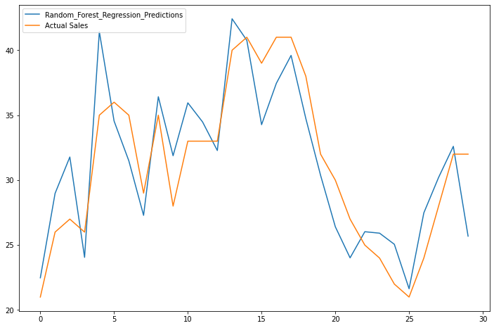

RMSE is: 3.0247897853190344

R2 is: 0.7200912570470113

MAPE is: 22.344304629759122

/usr/local/lib/python3.7/dist-packages/sklearn/utils/validation.py:760: DataConversionWarning: A column-vector y was passed when a 1d array was expected. Please change the shape of y to (n_samples, ), for example using ravel().

y = column_or_1d(y, warn=True)

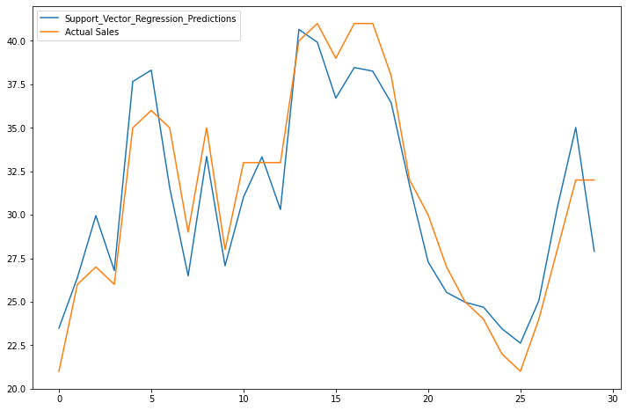

RMSE is: 2.097270304988795

R2 is: 0.8523071173111988

MAPE is: 22.25206133422374

The time series considered is: r4mw

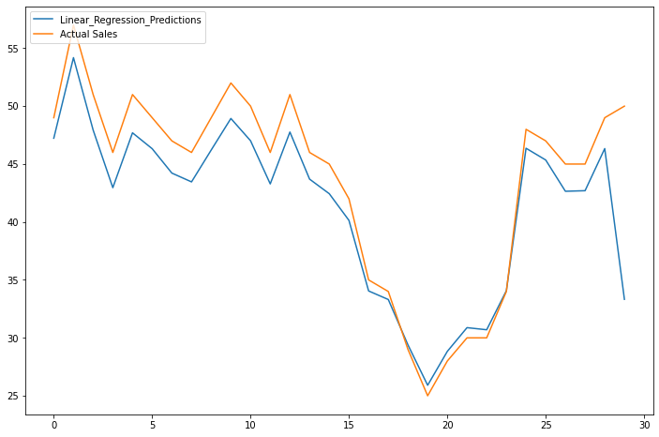

RMSE is: 3.772273156670509

R2 is: 0.7254997165101675

MAPE is: 6.220905310755531

/usr/local/lib/python3.7/dist-packages/ipykernel_launcher.py:48: DataConversionWarning: A column-vector y was passed when a 1d array was expected. Please change the shape of y to (n_samples,), for example using ravel().

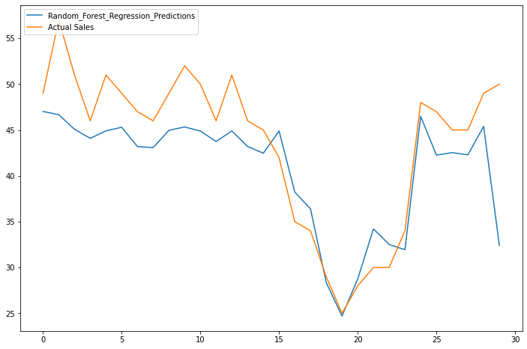

RMSE is: 5.103475778547619

R2 is: 0.3275198303765213

MAPE is: 23.46816019523021

/usr/local/lib/python3.7/dist-packages/sklearn/utils/validation.py:760: DataConversionWarning: A column-vector y was passed when a 1d array was expected. Please change the shape of y to (n_samples, ), for example using ravel().

y = column_or_1d(y, warn=True)

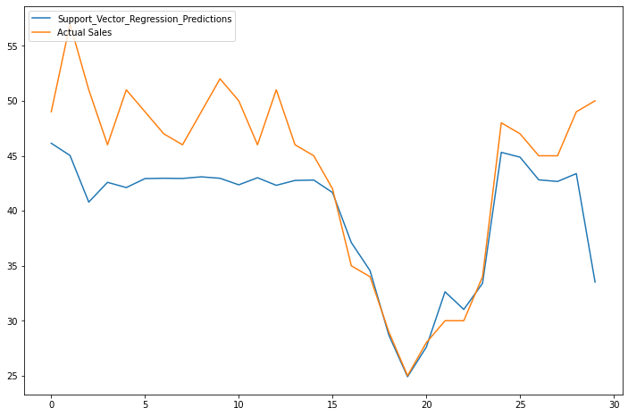

RMSE is: 5.839243125838339

R2 is: -0.02389861815683436

MAPE is: 24.871738869383737

The time series considered is: r1m

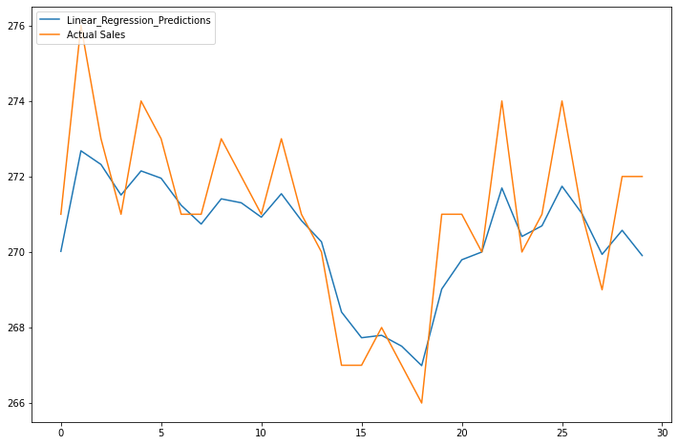

RMSE is: 1.287742483236768

R2 is: 0.23380757484252113

MAPE is: 0.36857279531382775

/usr/local/lib/python3.7/dist-packages/ipykernel_launcher.py:48: DataConversionWarning: A column-vector y was passed when a 1d array was expected. Please change the shape of y to (n_samples,), for example using ravel().

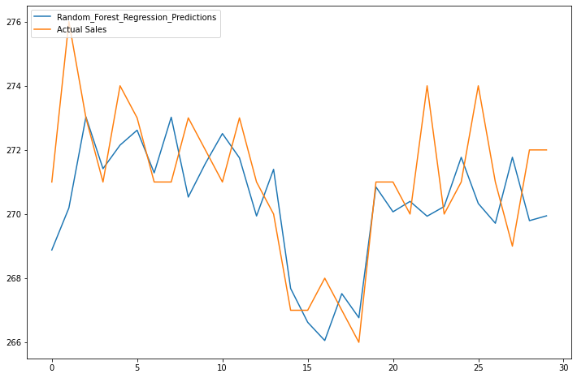

RMSE is: 1.9552781740389829

R2 is: -0.12448784813734881

MAPE is: 0.8867889828231976

/usr/local/lib/python3.7/dist-packages/sklearn/utils/validation.py:760: DataConversionWarning: A column-vector y was passed when a 1d array was expected. Please change the shape of y to (n_samples, ), for example using ravel().

y = column_or_1d(y, warn=True)

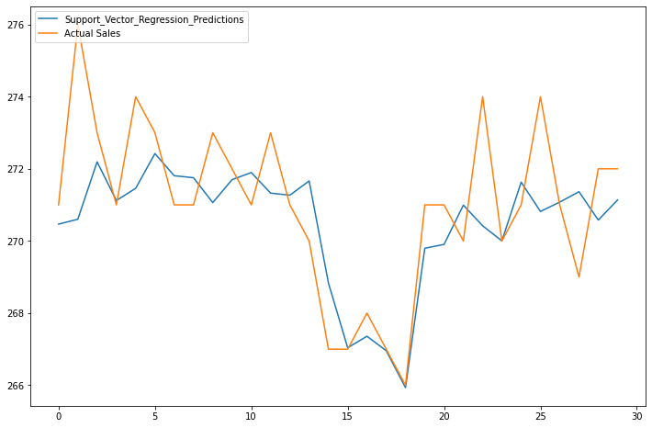

RMSE is: 1.7079419050088132

R2 is: -0.09789656851992312

MAPE is: 0.8172732200162844

The time series considered is: r2m

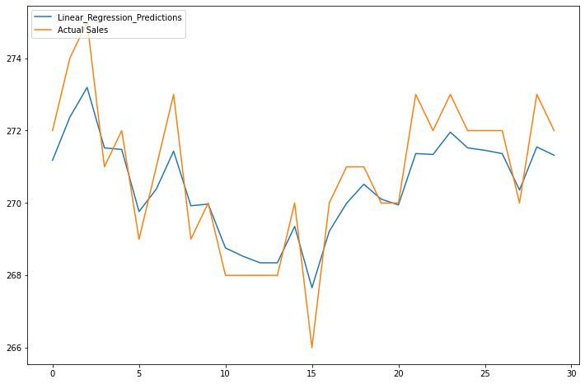

RMSE is: 0.9197570461626008

R2 is: 0.5046100940830281

MAPE is: 0.28815306558250564

/usr/local/lib/python3.7/dist-packages/ipykernel_launcher.py:48: DataConversionWarning: A column-vector y was passed when a 1d array was expected. Please change the shape of y to (n_samples,), for example using ravel().

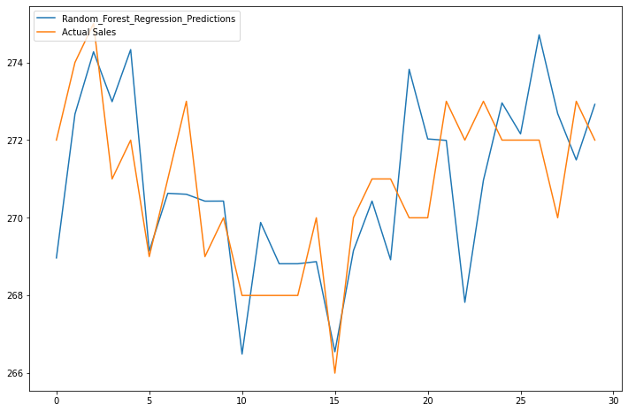

RMSE is: 1.853328277452761

R2 is: 0.29359438016406003

MAPE is: 0.8940498888054297

/usr/local/lib/python3.7/dist-packages/sklearn/utils/validation.py:760: DataConversionWarning: A column-vector y was passed when a 1d array was expected. Please change the shape of y to (n_samples, ), for example using ravel().

y = column_or_1d(y, warn=True)

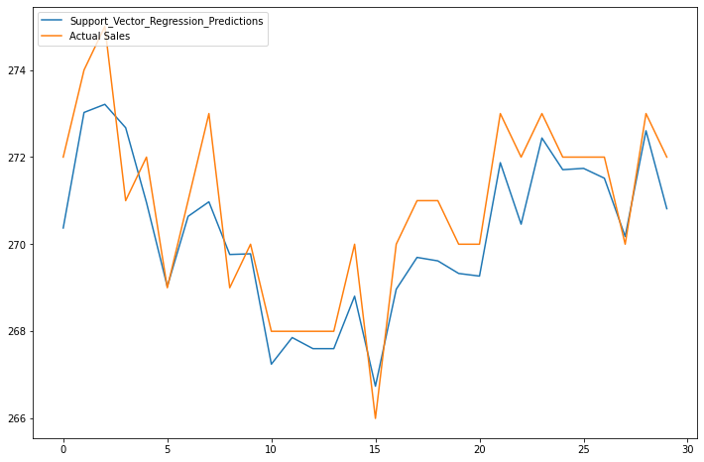

RMSE is: 1.0006186565618096

R2 is: 0.6739370896334945

MAPE is: 0.8219986026181032

The time series considered is: r3m

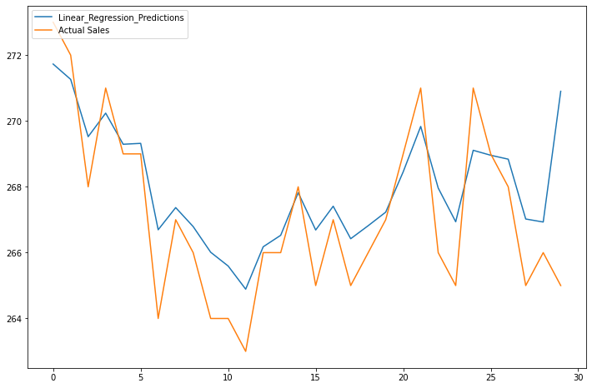

RMSE is: 1.662032964212315

R2 is: 0.06226893124323141

MAPE is: 0.45936140886314897

/usr/local/lib/python3.7/dist-packages/ipykernel_launcher.py:48: DataConversionWarning: A column-vector y was passed when a 1d array was expected. Please change the shape of y to (n_samples,), for example using ravel().

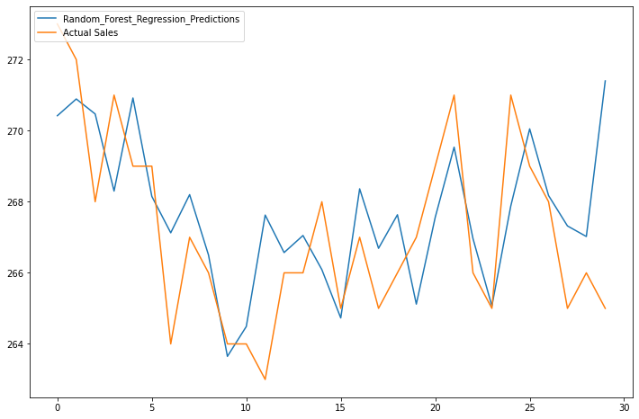

RMSE is: 2.1474165281468385

R2 is: -0.18205397077184582

MAPE is: 0.9962227826133667

/usr/local/lib/python3.7/dist-packages/sklearn/utils/validation.py:760: DataConversionWarning: A column-vector y was passed when a 1d array was expected. Please change the shape of y to (n_samples, ), for example using ravel().

y = column_or_1d(y, warn=True)

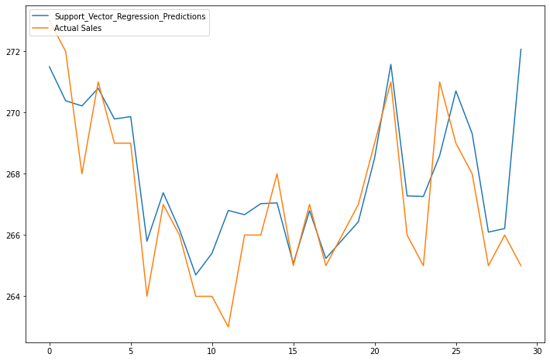

RMSE is: 1.8560042672284303

R2 is: 0.2609503061351769

MAPE is: 1.0301662026294127

The time series considered is: r4m

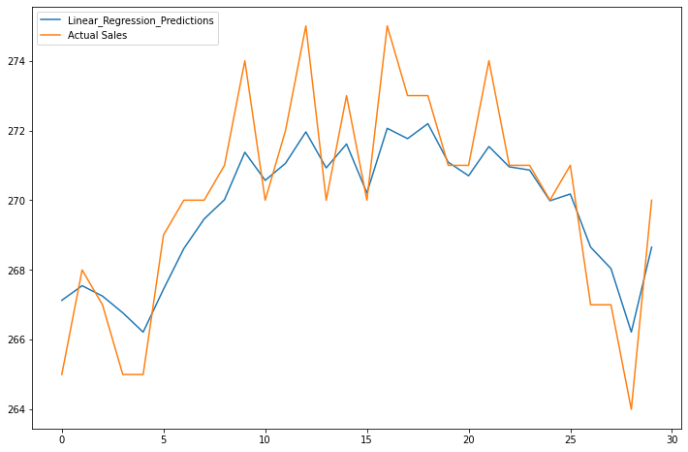

RMSE is: 1.4534784993059124

R2 is: 0.38505036879239707

MAPE is: 0.4336197646626778

/usr/local/lib/python3.7/dist-packages/ipykernel_launcher.py:48: DataConversionWarning: A column-vector y was passed when a 1d array was expected. Please change the shape of y to (n_samples,), for example using ravel().

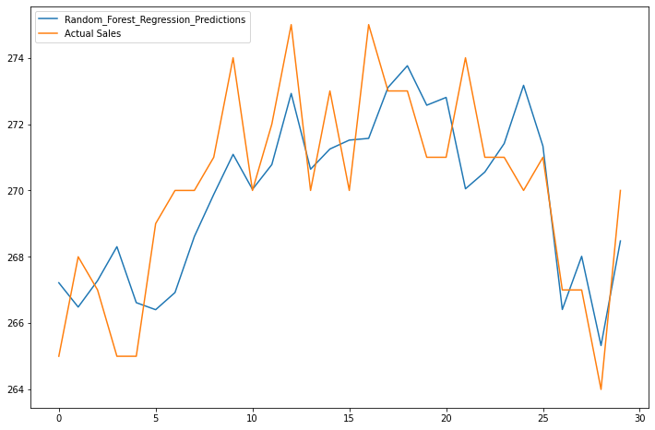

RMSE is: 1.9142478297502936

R2 is: 0.37428724905345523

MAPE is: 1.1495758322841068

/usr/local/lib/python3.7/dist-packages/sklearn/utils/validation.py:760: DataConversionWarning: A column-vector y was passed when a 1d array was expected. Please change the shape of y to (n_samples, ), for example using ravel().

y = column_or_1d(y, warn=True)

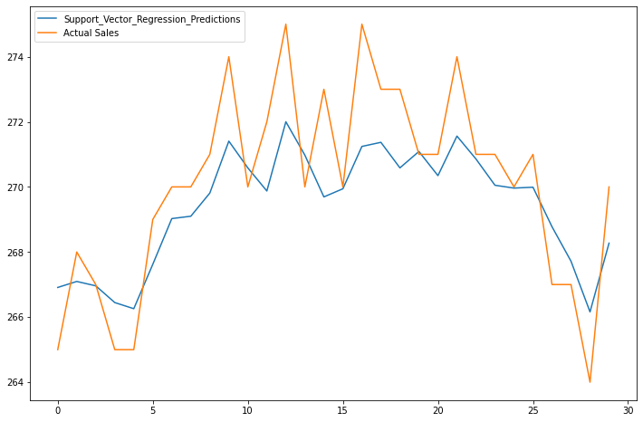

RMSE is: 1.711989864737089

R2 is: 0.02527226777186964

MAPE is: 1.0439088441473905

The time series considered is: r1c

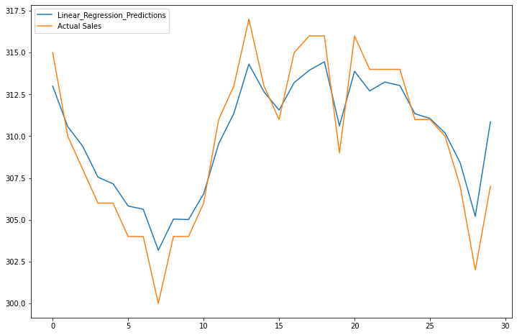

RMSE is: 1.7165543463361894

R2 is: 0.719915084318863

MAPE is: 0.4715772797208468

/usr/local/lib/python3.7/dist-packages/ipykernel_launcher.py:48: DataConversionWarning: A column-vector y was passed when a 1d array was expected. Please change the shape of y to (n_samples,), for example using ravel().

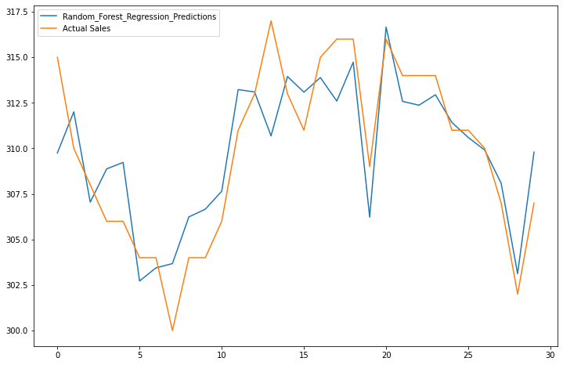

RMSE is: 2.3840290440594263

R2 is: 0.577844892905655

MAPE is: 1.5678509641002232

/usr/local/lib/python3.7/dist-packages/sklearn/utils/validation.py:760: DataConversionWarning: A column-vector y was passed when a 1d array was expected. Please change the shape of y to (n_samples, ), for example using ravel().

y = column_or_1d(y, warn=True)

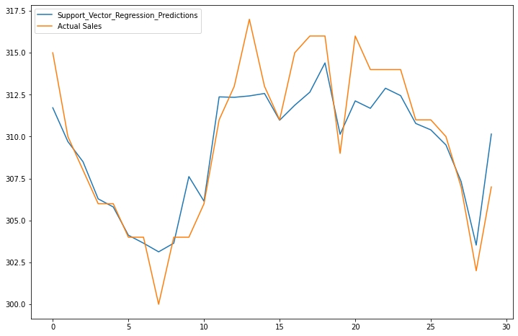

RMSE is: 1.9971004870222382

R2 is: 0.6416006824492437

MAPE is: 1.5311970538648048

The time series considered is: r2c

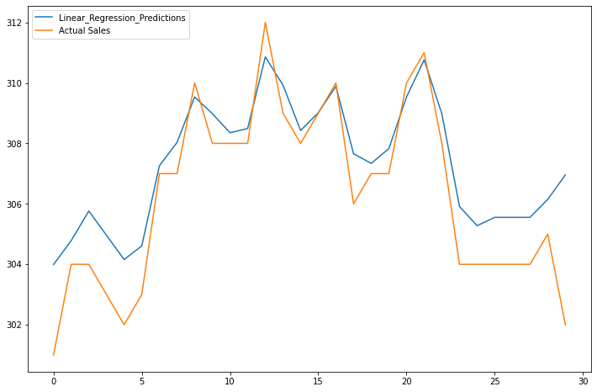

RMSE is: 1.5495128540565088

R2 is: 0.40179413682829723

MAPE is: 0.39099392064414235

/usr/local/lib/python3.7/dist-packages/ipykernel_launcher.py:48: DataConversionWarning: A column-vector y was passed when a 1d array was expected. Please change the shape of y to (n_samples,), for example using ravel().

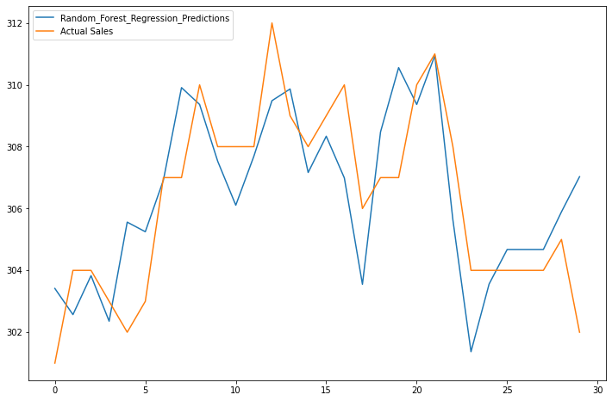

RMSE is: 1.979390454871661

R2 is: 0.41781317231003146

MAPE is: 1.037448062499784

/usr/local/lib/python3.7/dist-packages/sklearn/utils/validation.py:760: DataConversionWarning: A column-vector y was passed when a 1d array was expected. Please change the shape of y to (n_samples, ), for example using ravel().

y = column_or_1d(y, warn=True)

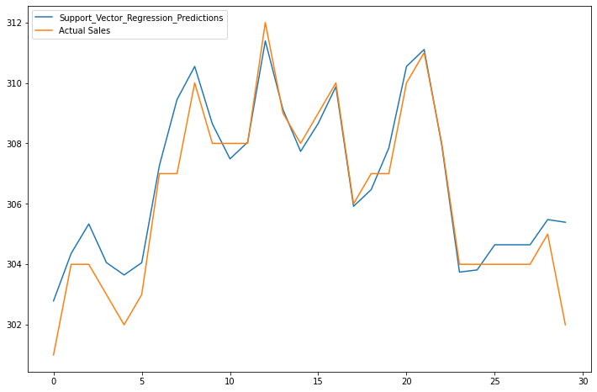

RMSE is: 1.0346680695668404

R2 is: 0.8290655616119652

MAPE is: 1.0236330790060921

The time series considered is: r3c

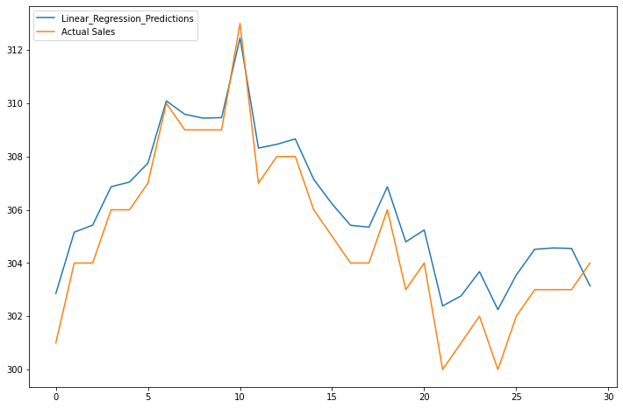

RMSE is: 1.3130153879606528

R2 is: 0.7377836203983518

MAPE is: 0.3909492152335575

/usr/local/lib/python3.7/dist-packages/ipykernel_launcher.py:48: DataConversionWarning: A column-vector y was passed when a 1d array was expected. Please change the shape of y to (n_samples,), for example using ravel().

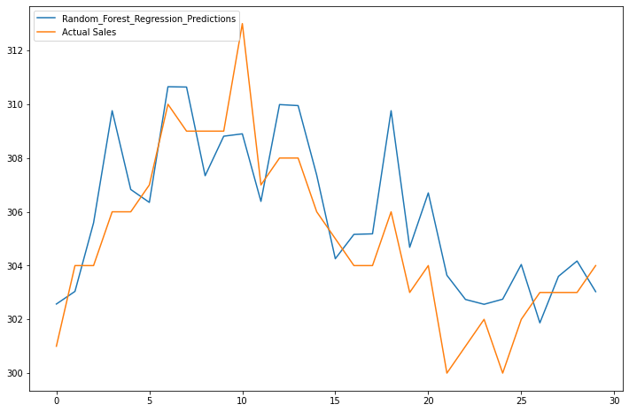

RMSE is: 1.946623550939957

R2 is: 0.5026389909249516

MAPE is: 1.1189006794381937

/usr/local/lib/python3.7/dist-packages/sklearn/utils/validation.py:760: DataConversionWarning: A column-vector y was passed when a 1d array was expected. Please change the shape of y to (n_samples, ), for example using ravel().

y = column_or_1d(y, warn=True)

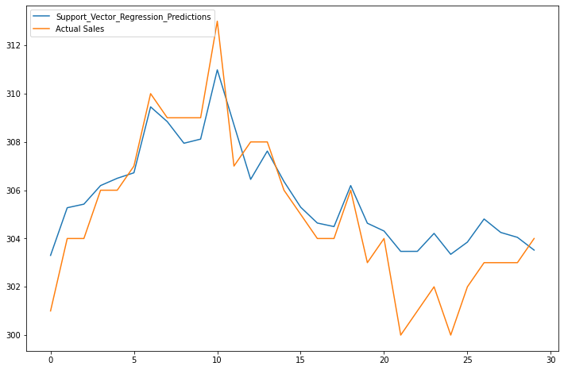

RMSE is: 1.511120922410946

R2 is: 0.4381796423098985

MAPE is: 0.9913256503689799

The time series considered is: r4c

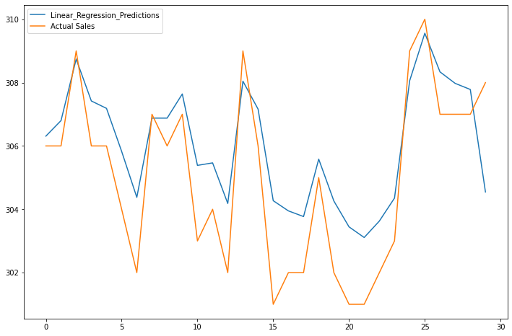

RMSE is: 1.669701006977256

R2 is: 0.14831268766874417

MAPE is: 0.47251979430396607

/usr/local/lib/python3.7/dist-packages/ipykernel_launcher.py:48: DataConversionWarning: A column-vector y was passed when a 1d array was expected. Please change the shape of y to (n_samples,), for example using ravel().

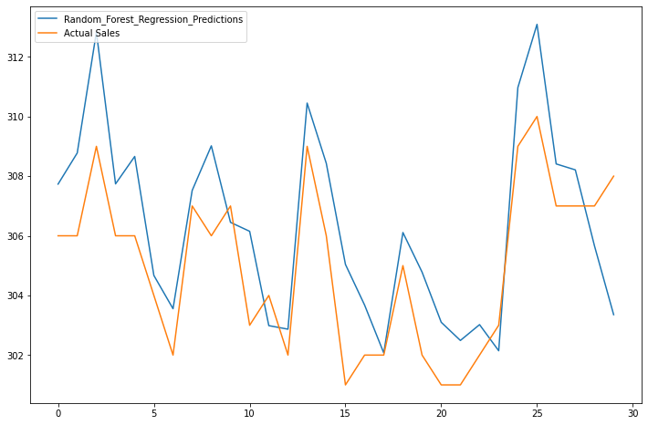

RMSE is: 2.194673126103788

R2 is: 0.4993518009910487

MAPE is: 1.134789613734297

/usr/local/lib/python3.7/dist-packages/sklearn/utils/validation.py:760: DataConversionWarning: A column-vector y was passed when a 1d array was expected. Please change the shape of y to (n_samples, ), for example using ravel().

y = column_or_1d(y, warn=True)

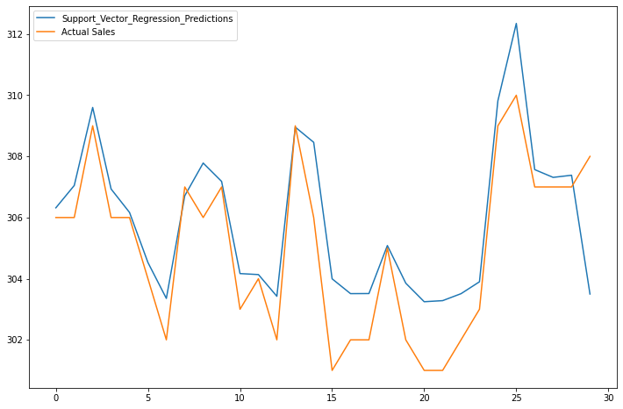

RMSE is: 1.5776444443160256

R2 is: 0.5654856712435992

MAPE is: 0.9911567051860425

The time series considered is: r1a

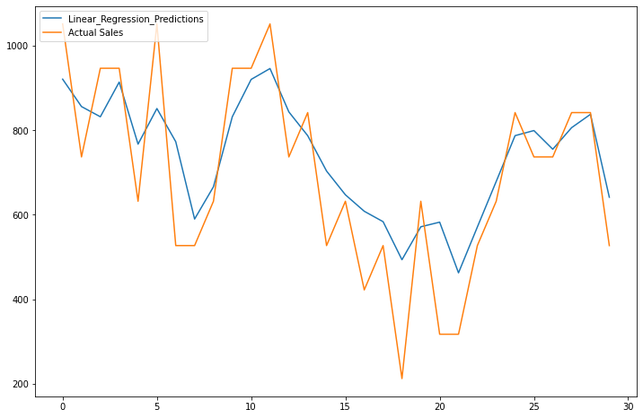

RMSE is: 126.32628057407749

R2 is: 0.09313163548701164

MAPE is: 14.956639467857476

/usr/local/lib/python3.7/dist-packages/ipykernel_launcher.py:48: DataConversionWarning: A column-vector y was passed when a 1d array was expected. Please change the shape of y to (n_samples,), for example using ravel().

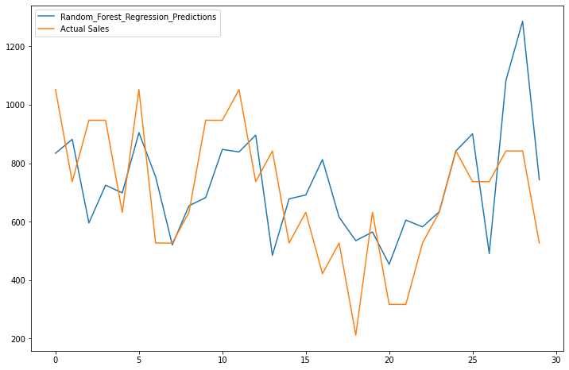

RMSE is: 215.08787916366882

R2 is: -0.396246281618446

MAPE is: 32.90584120913847

/usr/local/lib/python3.7/dist-packages/sklearn/utils/validation.py:760: DataConversionWarning: A column-vector y was passed when a 1d array was expected. Please change the shape of y to (n_samples, ), for example using ravel().

y = column_or_1d(y, warn=True)

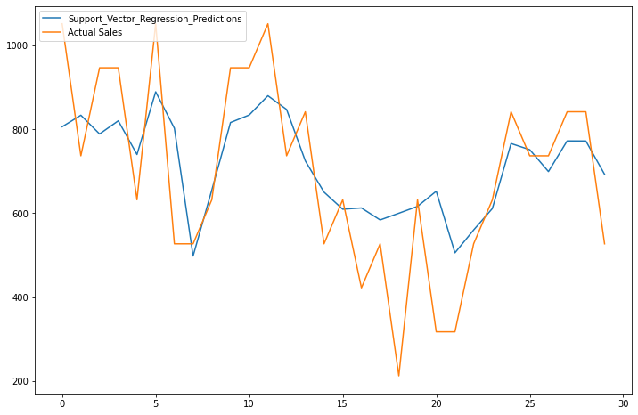

RMSE is: 153.99612638783663

R2 is: -0.9881924914179183

MAPE is: 29.561347001062916

The time series considered is: r2a

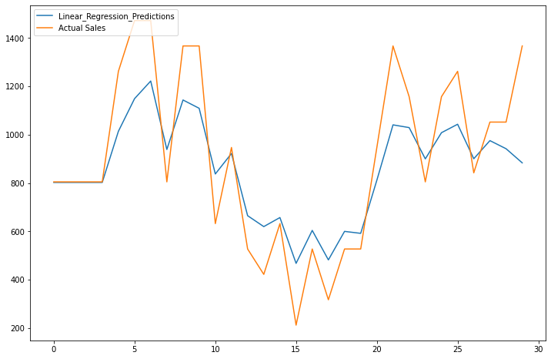

RMSE is: 186.92125383464

R2 is: 0.11649014150043568

MAPE is: 17.575542490207138

/usr/local/lib/python3.7/dist-packages/ipykernel_launcher.py:48: DataConversionWarning: A column-vector y was passed when a 1d array was expected. Please change the shape of y to (n_samples,), for example using ravel().

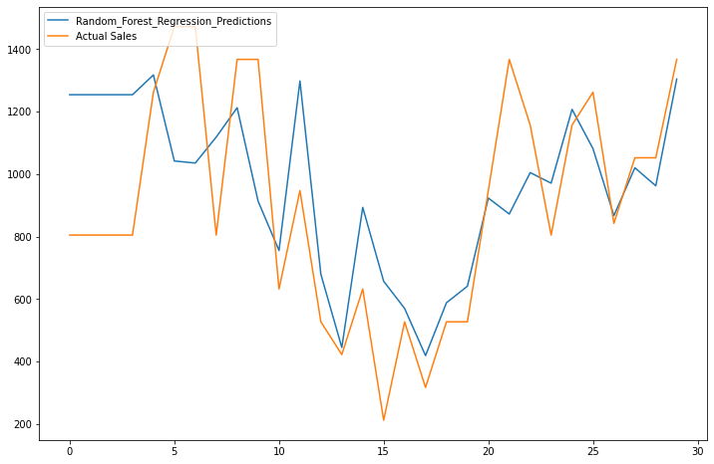

RMSE is: 277.89907380940474

R2 is: -0.11617973599185238

MAPE is: 42.867936180059175

/usr/local/lib/python3.7/dist-packages/sklearn/utils/validation.py:760: DataConversionWarning: A column-vector y was passed when a 1d array was expected. Please change the shape of y to (n_samples, ), for example using ravel().

y = column_or_1d(y, warn=True)

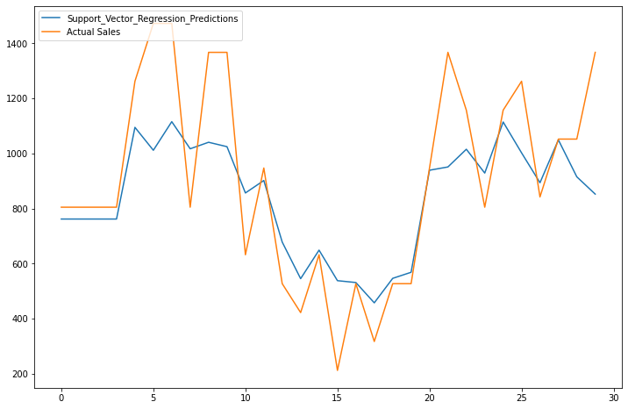

RMSE is: 218.10461656790477

R2 is: -0.22918246553104415

MAPE is: 44.52769503200866

The time series considered is: r3a

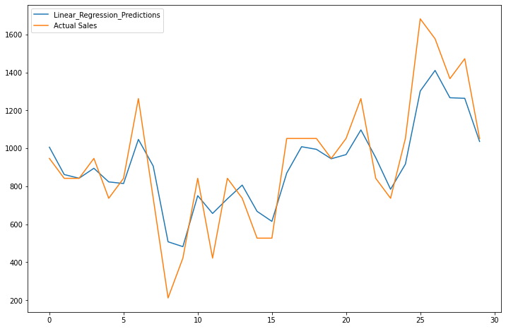

RMSE is: 143.77048586744277

R2 is: 0.5631489225251438

MAPE is: 13.295982033042486

/usr/local/lib/python3.7/dist-packages/ipykernel_launcher.py:48: DataConversionWarning: A column-vector y was passed when a 1d array was expected. Please change the shape of y to (n_samples,), for example using ravel().

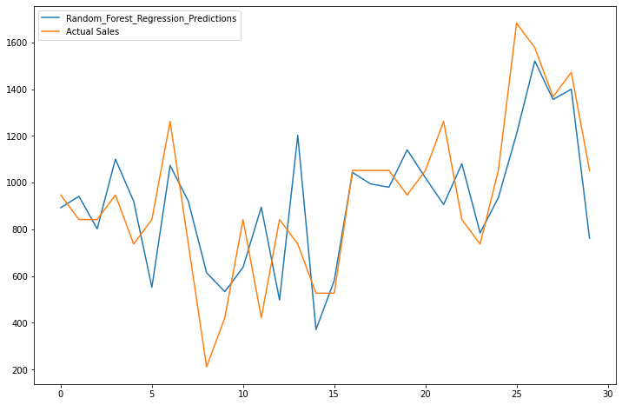

RMSE is: 230.19705955393255

R2 is: 0.28371038588306796

MAPE is: 42.742823961991576

/usr/local/lib/python3.7/dist-packages/sklearn/utils/validation.py:760: DataConversionWarning: A column-vector y was passed when a 1d array was expected. Please change the shape of y to (n_samples, ), for example using ravel().

y = column_or_1d(y, warn=True)

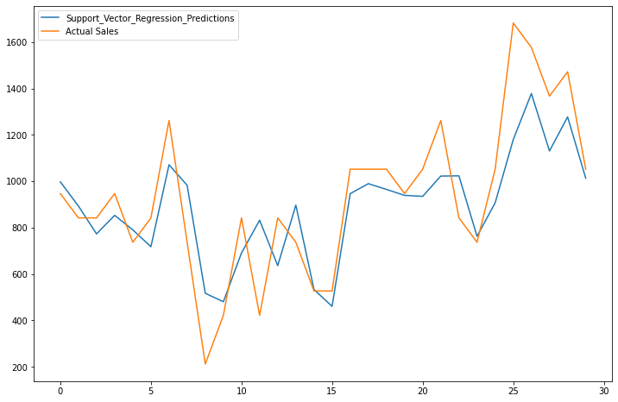

RMSE is: 185.24873390756042

R2 is: 0.2912481168127903

MAPE is: 39.90809731124633

The time series considered is: r4a

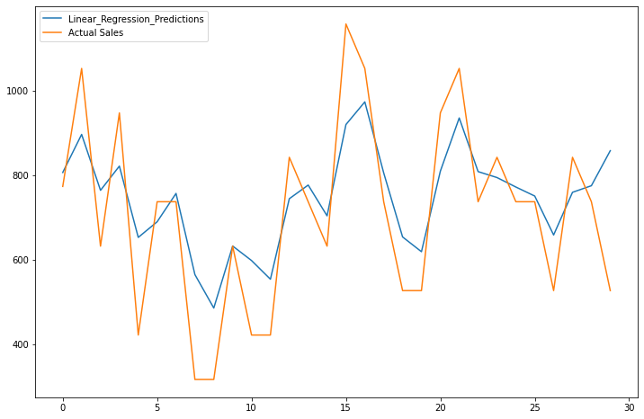

RMSE is: 133.8267795522933

R2 is: -0.3554237636978774

MAPE is: 15.363162905548538

/usr/local/lib/python3.7/dist-packages/ipykernel_launcher.py:48: DataConversionWarning: A column-vector y was passed when a 1d array was expected. Please change the shape of y to (n_samples,), for example using ravel().

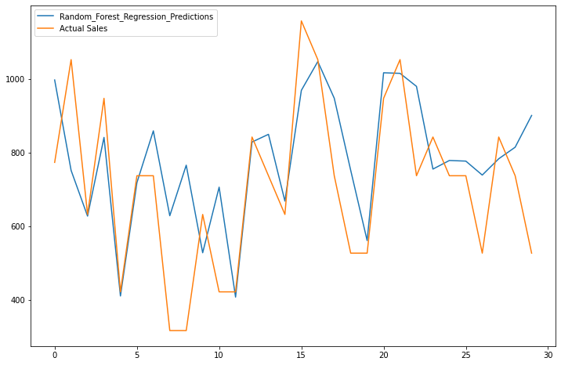

RMSE is: 180.00015719972714

R2 is: -0.180280634458011

MAPE is: 30.901222854405358

/usr/local/lib/python3.7/dist-packages/sklearn/utils/validation.py:760: DataConversionWarning: A column-vector y was passed when a 1d array was expected. Please change the shape of y to (n_samples, ), for example using ravel().

y = column_or_1d(y, warn=True)

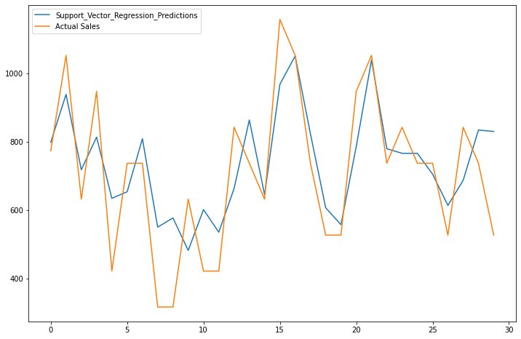

RMSE is: 135.76890697313416

R2 is: 0.1196203925128635

MAPE is: 29.74499564125527